Assignment 1: Introduction

Please include a photo of yourself (if someone else is in the picture, please identify yourself somehow)

Must include:

* Name, include your preferred name if you have one
* Pronouns
* Major
* Career plans
* Why are you in CSC 4500?
* Non-career related goals
* Are you part of any organizations through AU?

Other things I might like to know about you:

* Where are you from?
* Hobbies, interests, talents
* Are you close with your family? Who do consider family? Do you have siblings?
* Do you have any pets?
* What do you like to watch on [insert streaming service]?
* What kind of music do you like? Who are your favorite artists? Favorite songs?
* What is the coolest place you’ve ever been?
* What place would you like to travel to most?
* What is your favorite food?
* What is your favorite season? Why?
* Do you have a favorite sport to watch? Do you have a favorite to play?
* Are you musically inclined? Can you play any instruments? Can you sing?
* What is your favorite color?
* What is your favorite ice-cream flavor?
* What’s your favorite drink? If you are 21 or older, what is your favorite alcoholic drink?
* Can you speak any other languages?
* What was your dream job as a kid?
* Who inspires you?
* Why did you pick Aurora University?
* Do you have a favorite historical period? Which is it and why?
* Who would play you if your life was a movie?
* What are some of your proudest accomplishments?
* What are your favorite sports teams? Have you always been a fan?
* What’s on your bucket list?

Introduction should be 12 pt font, single spaced, 1 page long. See example attached.

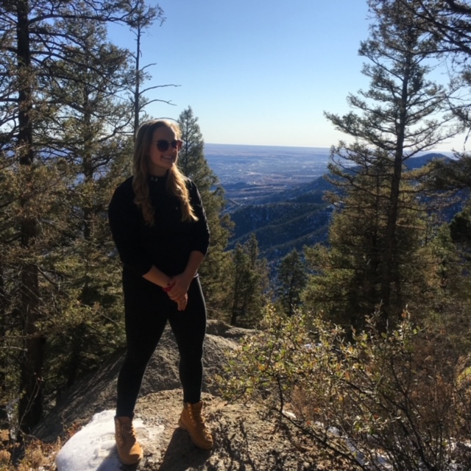Hello! My name is Casey Walters, and I am your CSC 4500 Instructor! My pronouns are She/Her/Hers. I graduated from Northern Illinois University with undergraduate degrees in Operations & Information Management, and Marketing. I continued my education at NIU and graduated with my Masters in Management Information Systems a year later. Currently, I am also a Workday Integrations Consultant at Alight Solutions. I am teaching CSC 4500 because I want to get my PhD and teach information systems later in my career.

Other things about me:

I am originally from St. Charles IL, and my parents still live there today. When I go visit, which is about once a week, I play my dad in pool. I am in the middle of a slight losing streak, but usually I win a solid 50% of the time! My mom and grandpa are big gardeners, so this year I have been participating in the hobby at their shared community garden plot. I am growing parsley, sage, basil, dill, cauliflower, and some peppers! I am nervous about the cauliflower plants; I have never actually heard of any of my gardener friends having any success with them.

My family consists of me, my mom and dad, and my sister Natalie. Natalie is 22 years old, and she is currently working in a mental health unit at a hospital in Grand Rapids MI. She wants to go to PA school to become a Physician’s Assistant.

I don’t personally have any pets, but my parents have a black cat named Kato. We think he has social anxiety, because he hides in the closet if anyone other than my parents are home. Natalie also has a black cat, appropriately named Ink, who is a jerk.

Right now I live in Dekalb IL with my friend/roommate Jillian. We lived together in college, and now that she’s getting her masters at NIU and my full-time position is virtual, I get my roomie back!

My Netflix/Hulu/Amazon Prime Video/etc favorites are Sex Education, Atypical, Big Mouth, Ted Lasso, and Kevin Can F\*\*\* Himself! But if I am working on something, I like having The Office, Parks and Rec, and Schitt’s Creek on in the background. My favorite movie is *Obvious Child*, which stars Jenny Slate (Missy from Big Mouth, or Mona Lisa from Parks and Rec!) and Jake Lacy (Pete from The Office).

I like indie folk-y music. Some of my favorite artists are Caamp, Rainbow Kitten Surprise, and Yoke Lore. But my all-time favorite artist is Taylor Swift! I have been a fan since I was 9 years old, and I constantly bore all my friends and family with facts about her songwriting and her life in general! If you are familiar with Taylor swift, my favorite song is probably Death by a Thousand Cuts. I also really like her song Renegade, which was released by Big Red Machine.

I’m looking forward to seeing you all in class this semester!